The EDITor is the desktop application used to edit data stored in the Common Data
Model (CDM) Community store. It edits data in either a remote source, or a local data
source embedded in the application.

For the installation please go to http:// http://cybertaxonomy.eu/download/taxeditor/workshop/ and download the file starting with “eu.etaxonomy.taxeditor.product.jre…” depending on your operating system.

Then unzip the file and go to the new created folder and start the editor with TaxonomicEditor.exe.
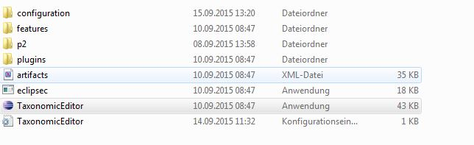

Go to the General Menu and choose “Connect”.
In the following dialog choose the server edit-WS I or edit-WS II and the datasource, the user is “admin” and the password “00000”. In the workshop you will get the name of datasource you will work on.

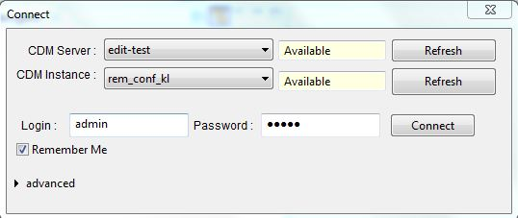

Now you are ready to use the EDITor!

Part0: The User Interface
We will give a short introduction on the functionality of the User Interface
- How do I open and close a View
  - Close and open the TaxonNavigator (open via Extras –> Show View -> Taxon Navigator)
- How do I open a Perspective
- The different views in the Taxonomic perspective and how to arrange them (move, maximize, …)

Part1: Taxonomy
For the workshop we provide you with a small dataset of four genera of the family Caryophyllaceae Juss.
To show you the taxonomic workflow with the EDITor we will add the information of two actual papers into our small classification. The papers you find in the download folder of the workshop.

Add a new name to Arenaria L.

- Please have a look at the paper “Arenaria acaulis (Caryophyllaceae), a new species from South Peru”
- To add a new child taxon to the genus Arenaria L., go to the Taxon Navigator, select the genus Arenaria L., open the menu with a right click and choose -> New -> Taxon
- Copy the whole name to the freetext field New Taxon and click Finish -> a new taxon appears and the name will be automatically atomized.
- Have a look at the details view on the right.
- Edit the authors and add the full names to the persons Daniel B. Montesinos-Tubée and Anneleen Kool
- Go to Nomenclatural Reference section in the details view, check whether the reference is atomized correctly. Maybe the reference could not be parsed. If so create a new reference: Create a new reference of the type article, add the title, author and inReference -> “Phytotaxa A rapid…”
- Add type informations, go to the Type Designations section and add the specimen information from the paper (for now we do not atomize the data, Atomization will be done in Part3)

Add type information to a genus

- To learn, how to add type name for a genus, go to the type designation section of Arenaria L. and add Arenaria serpyllifolia L. as lectotype. The Editor automatically recognizes that Arenaria is a genus and therefore it’s type is a species not a specimen!
- Add reference for the lectotype “Hitchcock, A. S. & M. L. Green. 1929. Standard species of Linnaean genera of Phanerogamae (1753-1754). 155. In Nom. Prop. Brit. Bot. His Majesty's Stationery Office, London. ”

New combinations of Arenaria species to Eremogone species (Paper “Eremogone (Caryophyllaceae): new combinations for Old World species”)

- Add a new name Arenaria aksayqingensis L.H.Zhou in the homotypical group of Eremogone aksayqingensis (L.H.Zhou) Rabeler & W.L.Wagner
- Add the reference “PhytoKeys 50: 37. 2015”
- Add the nomenclatural status “comb. nov.” (not really needed as taxon is already published! But if you would use the platform for publication and you are the author of the new combination, you would add the nom. status)
- Go to Arenaria aksayqingensis L.H.Zhou and click Switch synonym with accepted name.
- Move the taxon to the new parent Eremogone Fenzl
- Close the name editor and reopen it. Set Arenaria aksayqingensis L.H.Zhou as basionym.

Adding name relationships: Add a later homonym to Arenaria L. -> go to the Name Relationship section -> click on the + and add a name relationship of type later homonym -> add the name Arenaria Opitz according to Nomenclator Zoologicus (add this as sec reference).

For adding a misapplied name go to Silene atocioides Boiss. -> right click in the freetext editor -> new -> misapplication -> Choose the name Silene schafta J.G.Gmel. & Hohen. Add the secundumg (sensu) reference “J.M.Black loc. cit.” to the misapplied name

Part 2: Factual Data, Term Editor and Bulk Editing
First we want to have a look at the possibilities to adapt the shown vocabulary:
- Go to Arenaria L. and try to add a common name -> Factual Data view -> New Factual Data, New -> Common Name
- Go to the details view -> click on the Language -> the system provides a really large amount of languages! But normally only a handful is needed.
- Go to the menu -> Windows -> Preferences and choose languages for example English, German, French
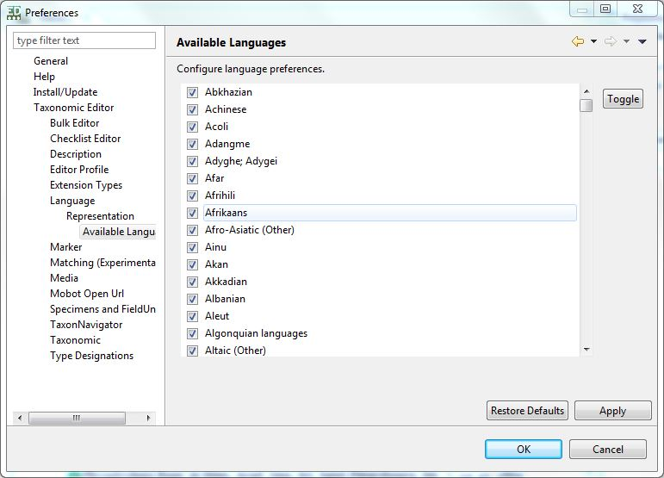
Go back to the common names and add for example English “sandwort”, German “Sandkräuter”, French “sablines”
Use again the paper about Arenaria acaulis and add factual data from the paper. Use the same workflow as for the common names.
Add distribution -> go to the details view -> open the selection dialog for the area
Add media e.g. for Arenaria bifloraL.
  - Add uri : https://upload.wikimedia.org/wikipedia/commons/8/8d/Arenaria_biflora.jpg
  - Add artist „Tigerente“

Term Editor
The EDITor provides many terms and vocabularies, however, sometimes it is needed to add new ones. To do so we can use the Term Editor. As an example we want to add a new feature for adding factual data.
Go to Window -> Term Editor -> Features
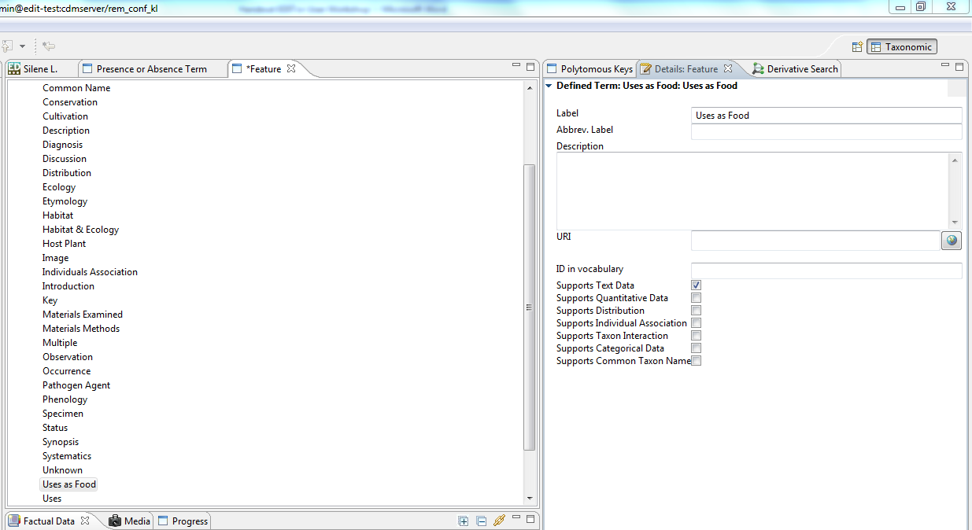
A new window shows the vocabularies Features and Name Features -> go to Features and open the menu with a right click -> New -> Defined Term
Edit the new defined term on the right side, for example create a new feature “Uses as Food”.
Set supports TextData.
As an example for quantitiative Data add a new feature “Leaf Length”, select “Supports Quantitative Data”, and then you can add the recommended measurement unit and the statistical measures. See the screenshot below.
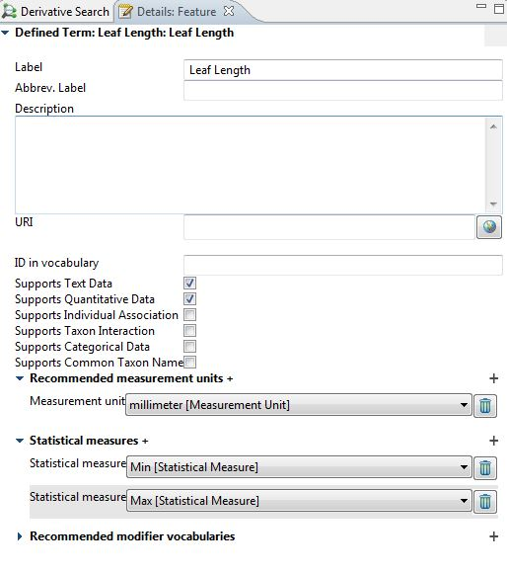
Go back to the factual data view and see that the new features appear in the selection of features.

Bulk editing
For editing larger amounts of data the bulk editor provides nice functionalities like deduplication, deleting or just editing the objects.
- Go to Window -> Bulk Editor -> Persons and Teams
- Enter “L.” and search
- Open the referencing objects view by right click -> Show in -> Referencing objects
- Deduplication->mark one record as target for deduplication and the other one as candidate for deduplication and click deduplicate group. Watch result in referencing objects view
- Edit the persons and teams, add Carl von Linné as full name
- Conversion of person to team and team to person -> Kleopow exists as a one person team -> convert into a person and convert back to team with according right click menu item
- Do some further deduplication, e.g. you may also deduplicate persons which also show up as teams

- Open the reference bulk editor
- Search for “Lagascalia”, sort by year
- A lot of references are listed, go to the first reference
- Go to http://www.biodiversitylibrary.org search for Lagascalia and look for the volume with the publication date 1974
- Change the type to book and add the volume information (4)
- Set as target for de-duplication
- Mark all references with the same publication date as candidates
- Click deduplication and save

Part 3 Specimen Data
The first step is to go to the already added specimen data and atomize the data. This will give us a short overview.
- Go to the Bulkeditor for Specimen and Observations (Window -> Bulk Editor -> Specimen and Observations)
- Search for all specimen with “*”
- Click on one of the specimen and go to the Details View and fill the details like in the screenshot below.
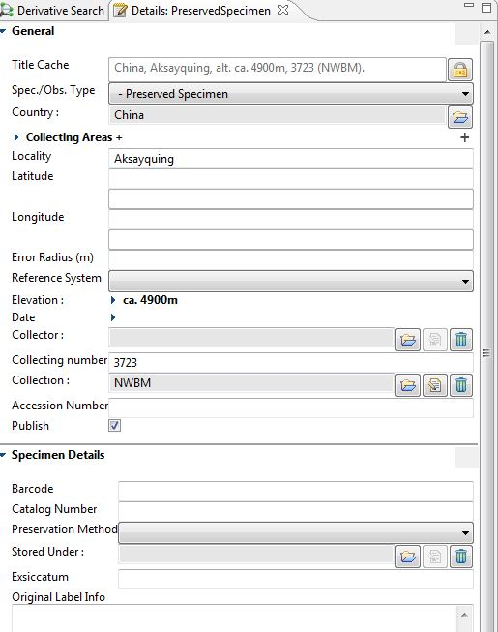
- In the details view you will see available (empty) parameters for the specimen
- The title cache field contains some atomic information about the specimen. Copy and paste them in the correct field in the details view (screenshot).
Note: Do not click the lock icon of the title cache field before you are finished. Doing so would set the title cache to be automatically generated from the single atomic fields.

- When you are done click the lock icon of the title cache field.

Import of specimens via ABCD
- Go to General->Taxonomic Editor->Import->Abcd Import
- On the first page check „Add Media as MediaSpecimen“ and „Map UnitID to accession number“
- Skip the second page
- On the third page leave the classification chooser empty (default classification will be created) and optionally select a report file (e.g. create an empty text file on your desktop)
- On the fourth page select the file Arenaria_ABCD_one_unit.xml an hit Finish.
- If you have selected a report file you can have a look at which taxa, names and specimens were created and whether there were problems during the import.
- Check the taxon navigator for the newly created taxa. Note: Do a right-click->Refresh on the new classification first.
- Open Arenaria serpyllifolia L. subsp. serpyllifolia and have look at the factual data view. You will see the recently imported specimen attached to this taxon.
- Now, if you search for '*' in the bulk editor you should also find the recently imported specimen. Note: The Search can be filtered. Searching for '*Rheinland*' for example will only retrieve the imported specimen.

Derivate hierarchy
- Select the taxon editor again and in the factual data view double-click on one specimen
- The derivative hierarchy of this specimen will be shown.
  - The FieldUnit containing information about the collector and the gathering
  - The specimen itself.
  - A specimen scan which was also imported because the information was part of the ABCD file. Note: Select the specimen scan in the hierarchy and in the details view click on the icon in the upper right corner. The details view will load a preview of the specimen scan.
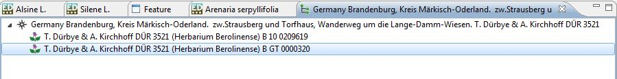

Specimen duplicates
We will import the same specimen again and pretend that it is a real duplicate of the other one.
- Select the specimen in the hierarchy and change the accession number in the details view (e.g. change the last digit to 0). That way we have can see a difference between the two specimen.
- Save.
- Repeat the import of step2 with the same file but uncheck the option „Ignore import of existing specimen“ and do not check „Add media as media specimen“.
- Note: In the report file (if specified) you can see that no taxon or name was created but only the specimen.
- In the factual data view of Arenaria serpyllifolia L. subsp. serpyllifolia you will now see two specimens.
- Select both of them and do a right-click and select „Open in specimen editor“
- In the derivative hierarchy you will see two field units with the same title, each with a specimen.
- Drag the one of the specimens to the other field unit.
- Right-Click->Delete the empty field unit. Now we have only one field unit with two specimen duplicates.

Import of DNA Data
- Repeat all steps of the import with the file Arenaria_DNA_ABCD_one_existing_one_not.xml
- Close all editors and re-open the taxon editor for Arenaria serpyllifolia L. subsp. serpyllifolia.
- Have a look at factual data view and open the imported unit.

